______________________________________________________________________________

BATTLE OF THE NEIGHBOURHOODS

**Varun Moturi**

ABSTRACT

*Greater Toronto Area (GTA) welcomes more than 100,000 immigrants every year. When migrating to a vast area like GTA, immigrants often find themselves in a dilemma when it comes to deciding a location to buy house. They would need to account for all the amenities in their neighbourhood including grocery stores, restaurants, movie theatres, etc. In order to help immigrants understand the neighbourhoods in GTA, I created a model that clusters similar neighbourhoods and visually represent them to the user.*

1. **INTRODUCTION**

1.1 ***Problem***

With a population of 2.7 million, Toronto is known to be the most populous city in Canada and fourth most populated city in North America. The city of Toronto is Toronto is part of the Greater Toronto Area (GTA) which includes the following regions:

* Halton
* Peel
* City of Toronto
* York
* Durham

These regions are further divided into subdivisions called Boroughs. Being the most populated area in Canada, GTA welcomes more than 100,000 immigrants every year. Immigrants usually face a challenge when it comes to choosing a neighbourhood which would best suit their need. Immigrant families tend to rent a room at a random location to get a better understanding of the city before they choose to settle in a neighbourhood. This can be solved by providing the immigrants with enough knowledge about all the neighbourhoods so they can choose the one that is best suited for them.

1. **DATA**

The data is scraped form a publicly available dataset on Wikipedia (<https://en.wikipedia.org/wiki/List_of_postal_codes_of_Canada:_M>). This dataset consists of the following attributes such as ‘Postal Codes’, ‘Borough’ and ‘Neighbourhood’. The dataset contains all the subdivisions of GTA along with its neighbourhoods. Google Maps Geocoding API will be leveraged to obtain the latitude and longitude of each neighbourhood. As described in the problem description, venues surrounding each neighbourhood will be retrieved using the Foursquare API. Neighbourhoods will then be clustered based on the venues surrounding then. Each Neighbourhood will be displayed with its most popular venues. A map of GTA will be displayed with similar neighbourhoods giving users more alternatives.

1. **DATA CLEANING**

The dataset retrieved a total of 180 postal codes from the online source. The dataset consisted of many missing values represented as ‘Not Assigned’.

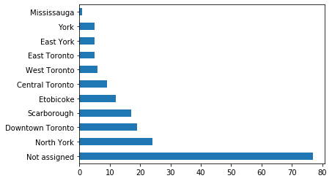

*Histogram of ‘Borough’ Column*

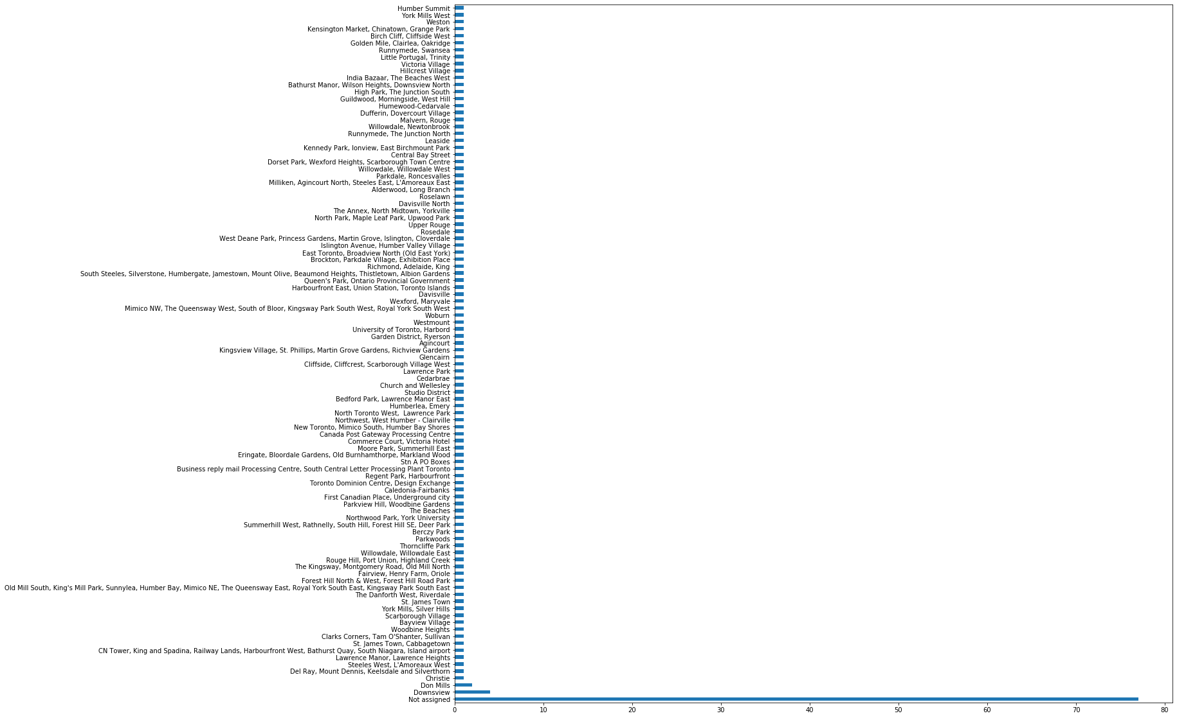

*Histogram of ‘Neighbourhood’ Column*

As seen above, there were approximately 77 Boroughs and Neighborhoods that were not assigned. To make the data more reliable, I dropped all the rows where ‘Borough’ was ‘Not Assigned’ and assigned ‘Borough’ as ‘Neighborhood’ if ‘Neighborhood’ was ‘Not Assigned’. This reduced the dataset from 180 rows to 103 rows.

1. **DATA CLUSTERING**

After retrieving the latitudes and longitudes of each neighborhood, the ‘follium’ library was used to plot them on a map.

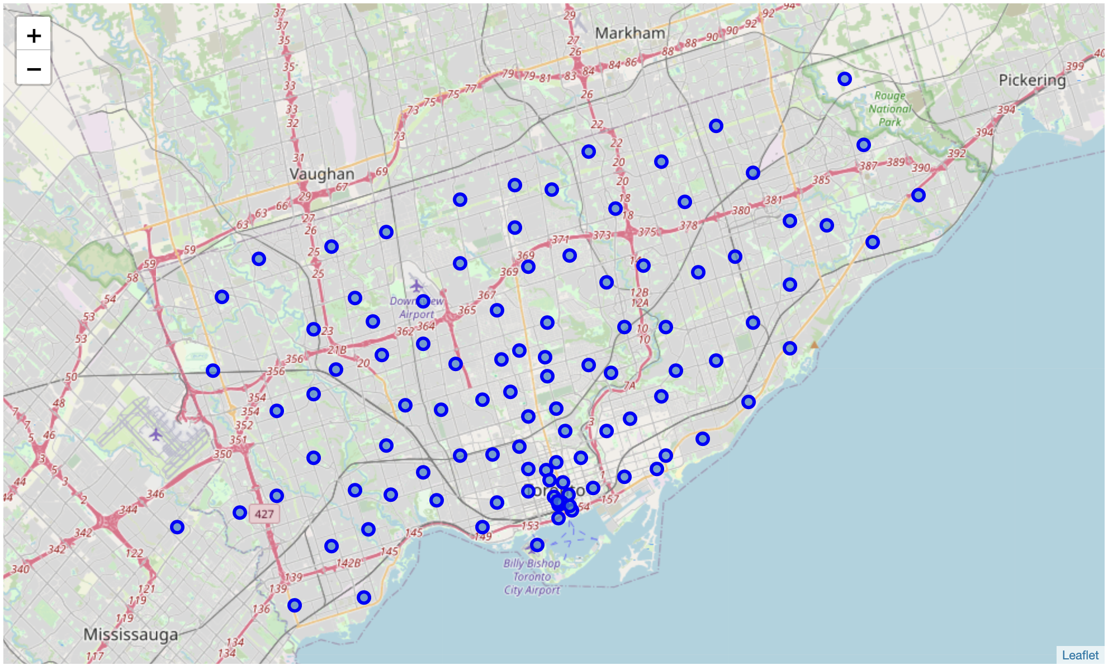

As shown above, the neighborhoods in the dataset are well dispersed throughout the Greater Toronto Area (GTA). The Foursquare API was used to get the points of interest (venues) which are located within 500 m of each neighbourhood. A total of 271 venue categories and 2124 venues were discovered through the Foursquare API.

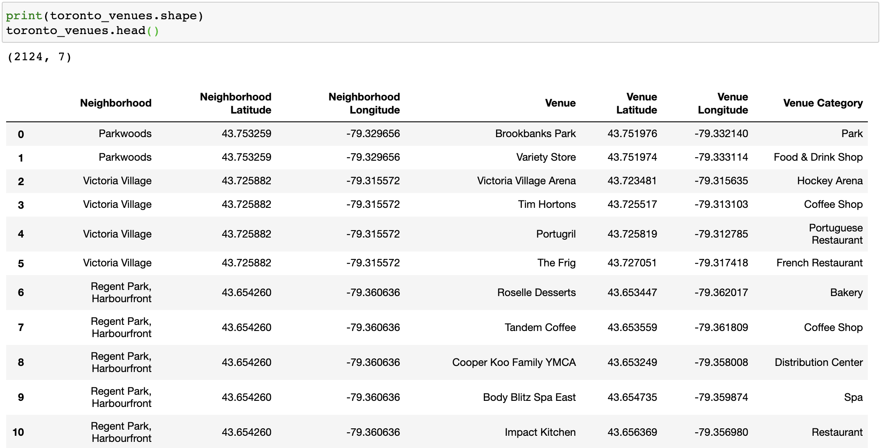

As the new dataset consisted of categorical variables, ‘one-hot encoding’ was performed to convert the categorical data to numerical data. The data was processed and grouped based the most occurring venue in each neighbourhood. In my case, I listed the top 10 most seen venues in each neighbourhood.

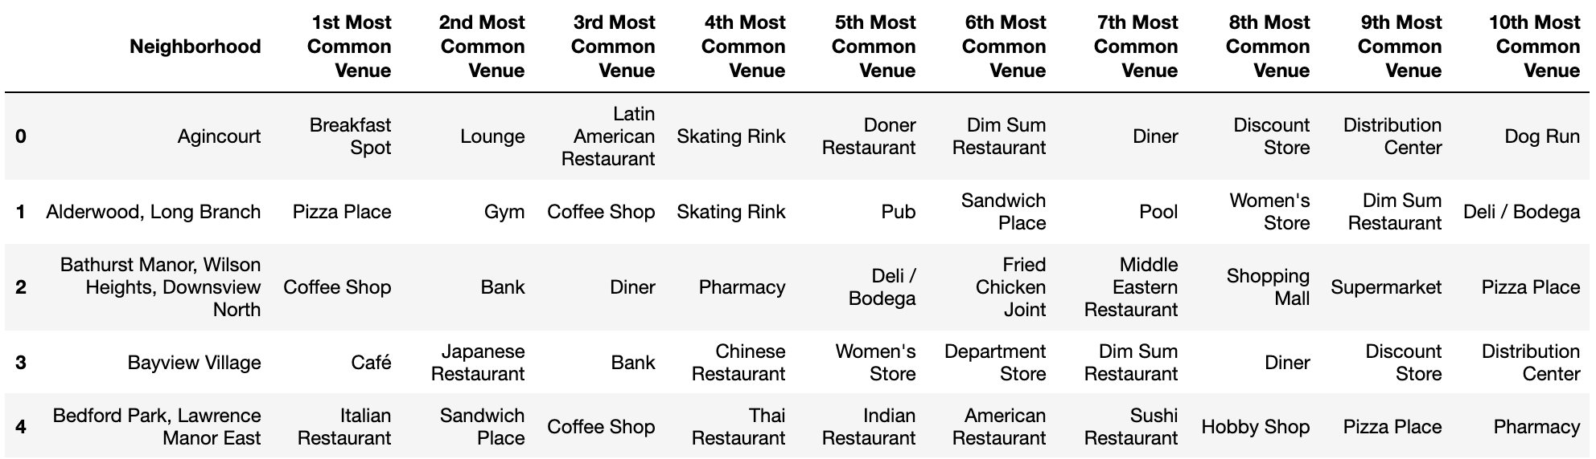

Histograms were created for all the columns in this dataset to visualize the top venues in each neighborhood

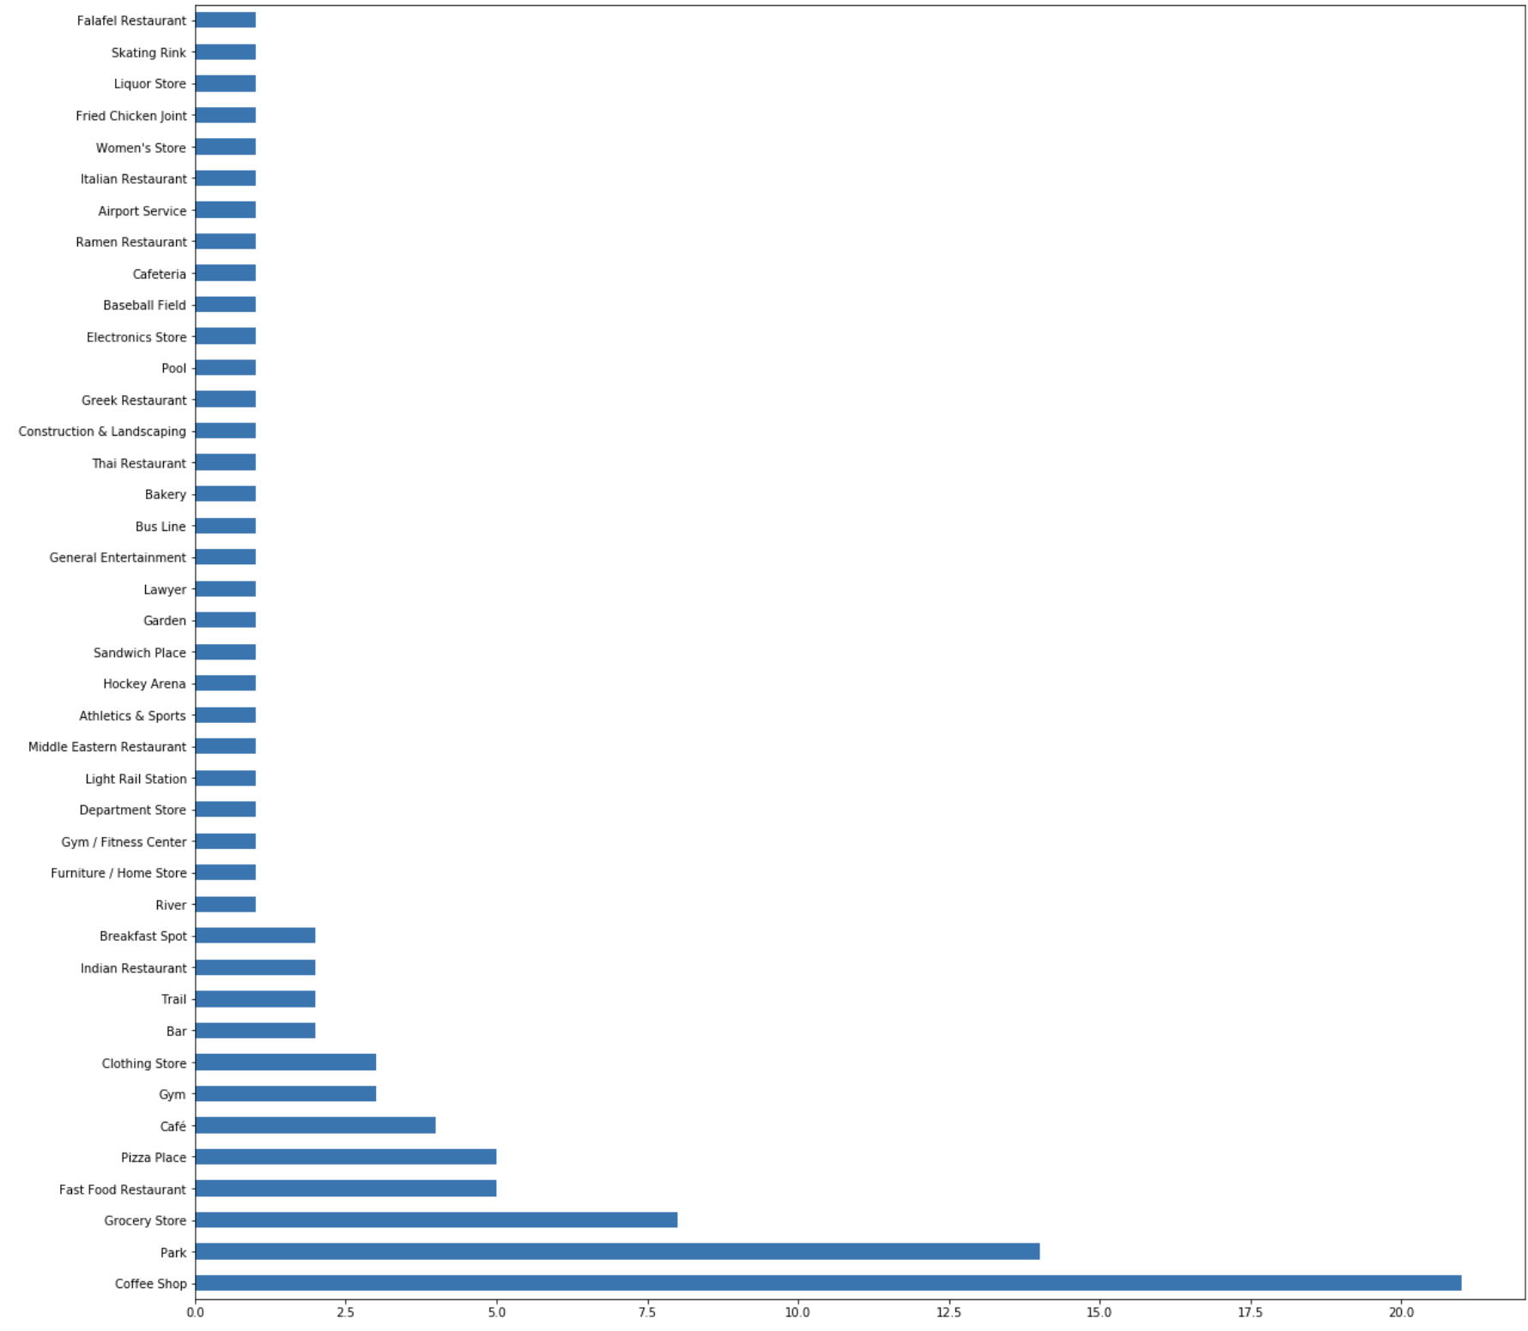

*1st Most Common Venue*

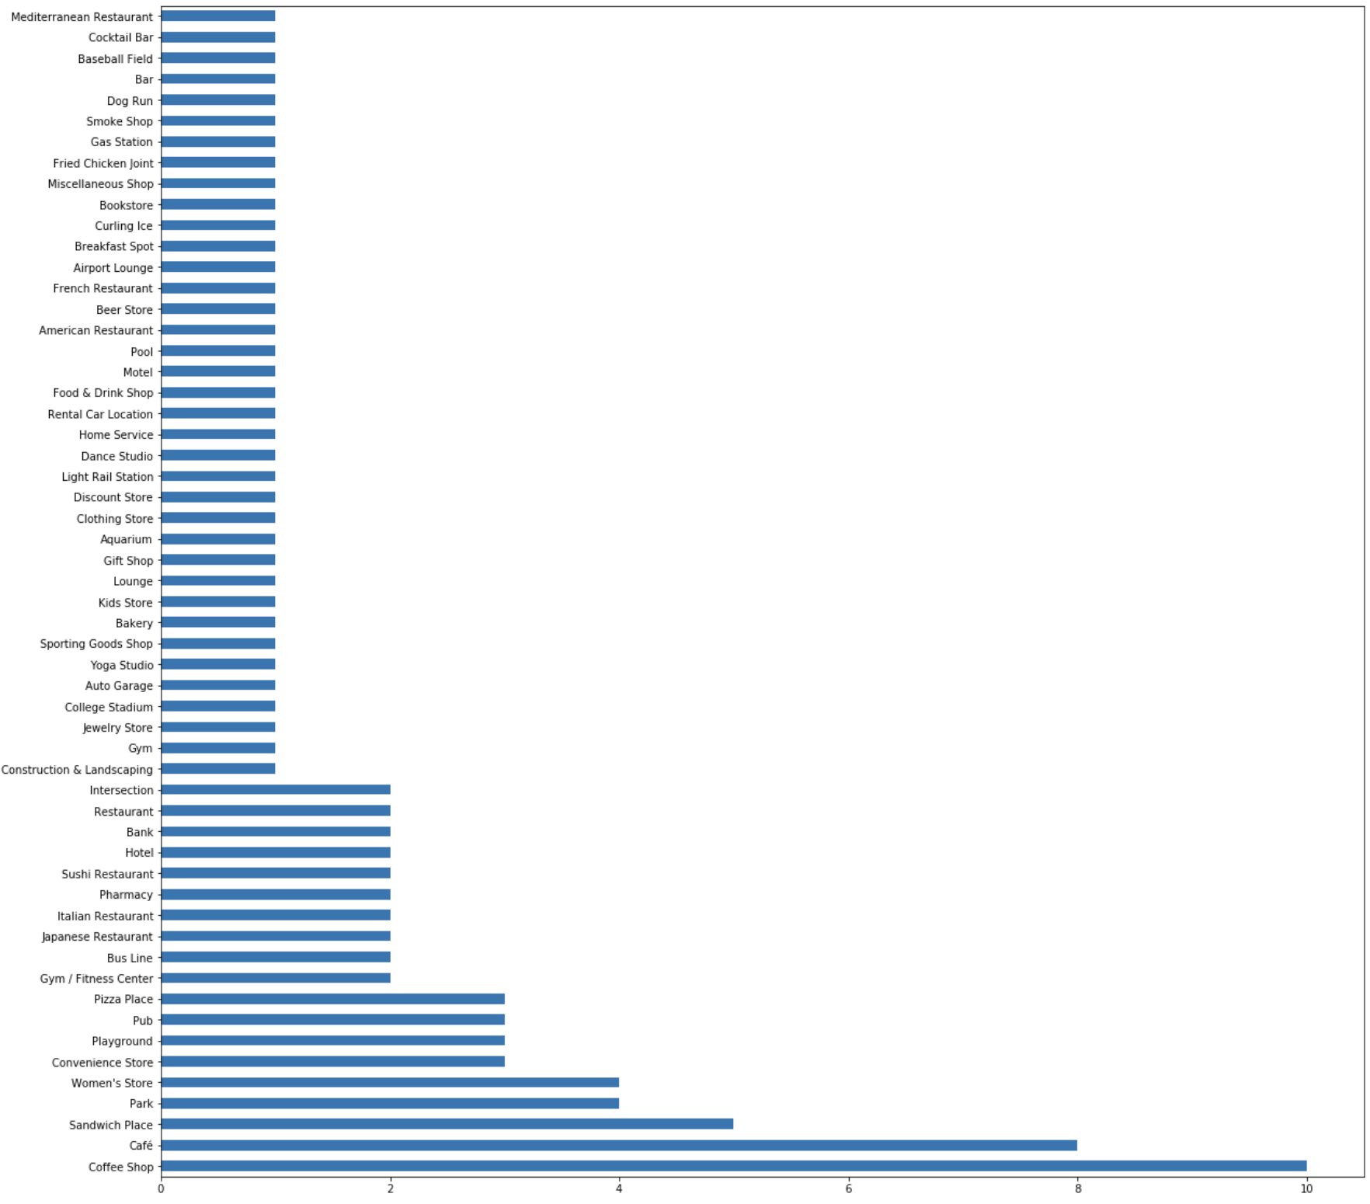

*2nd Most Common Venue*

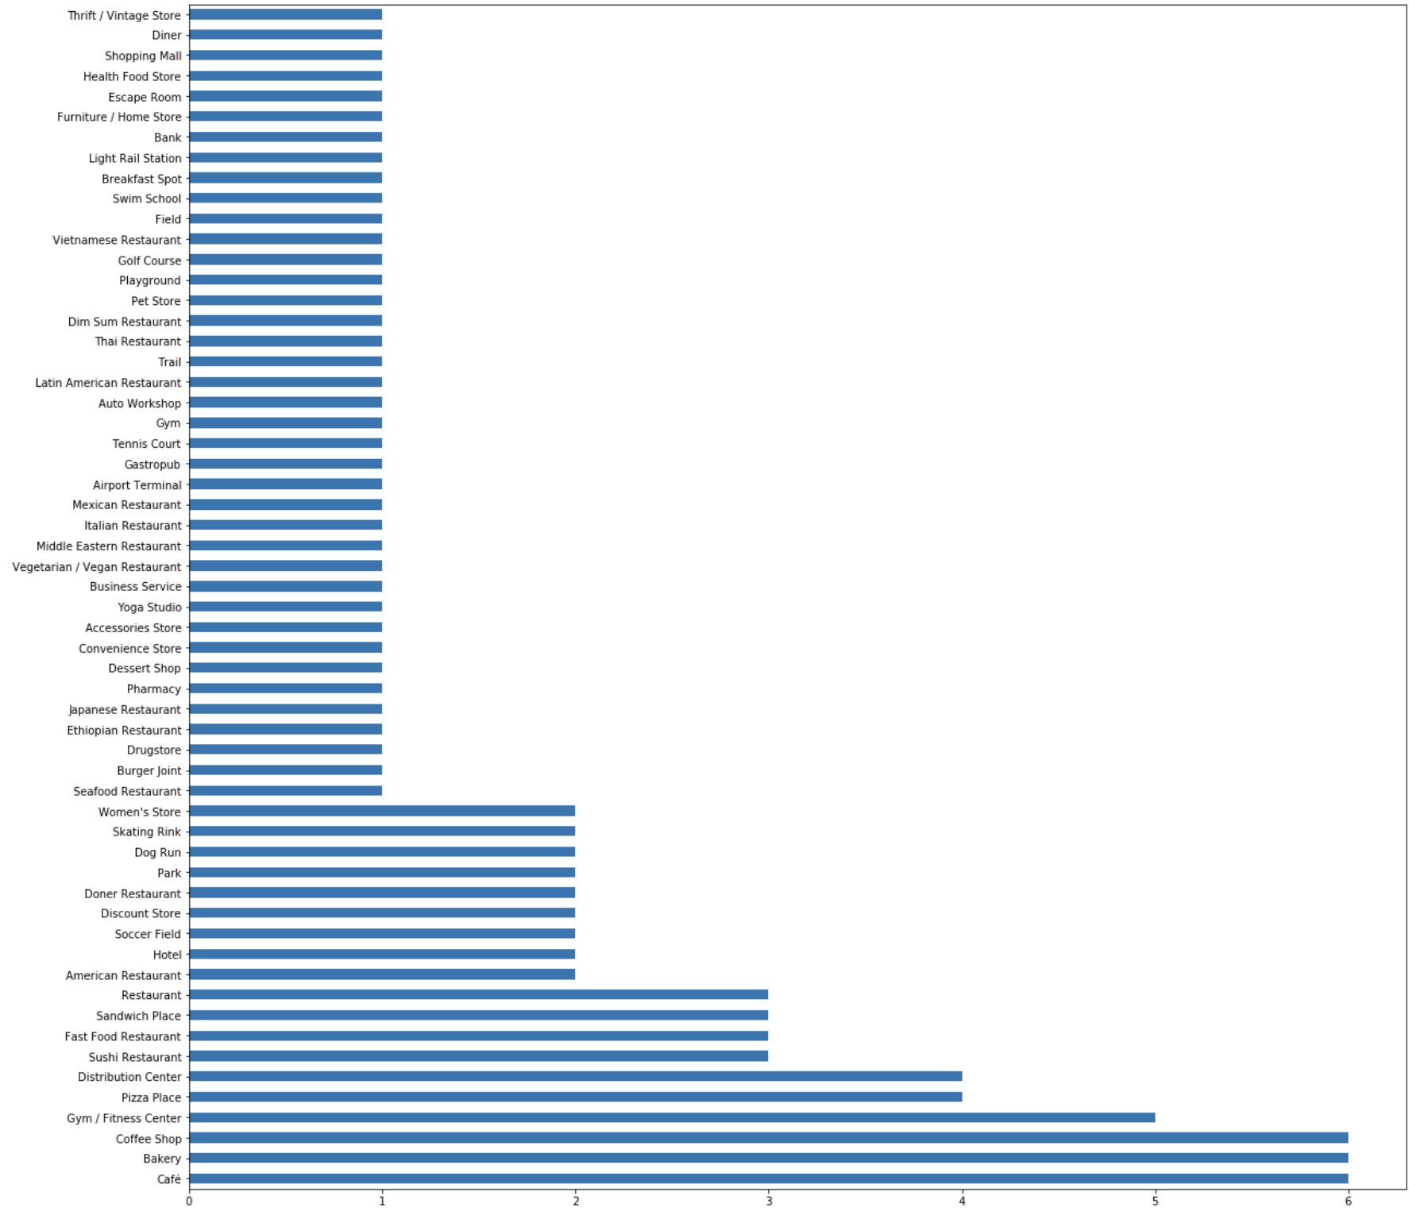

*3rd Most Common Venue*

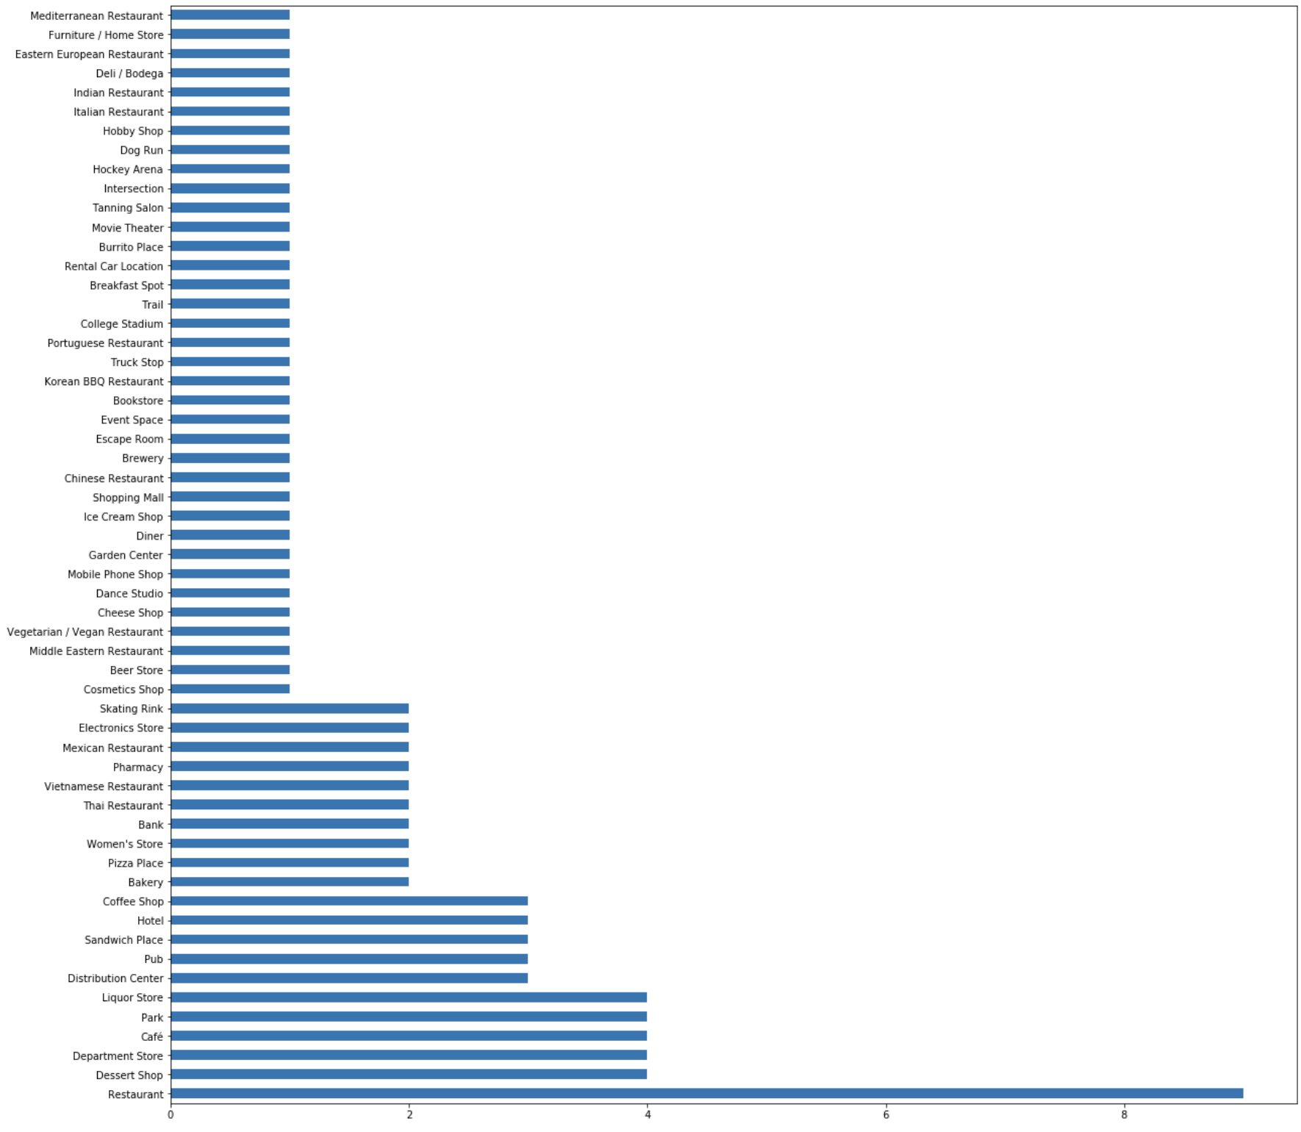

*4th Most Common Venue*

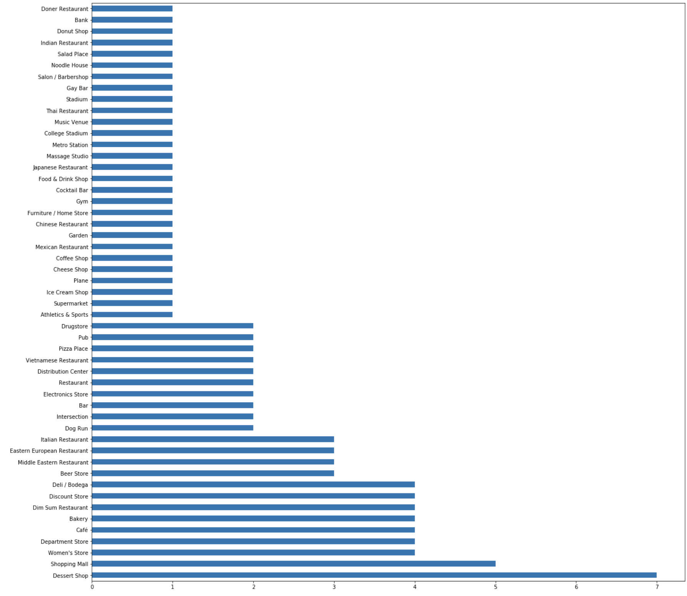

*5th Most Common Venue*

As seen above, ‘Coffee shop’ ranked 1st and 2nd among the most common venues followed by ‘Café’, ‘Restaurant’ and ‘Desert Shop’. Looking at the data, the user can understand that most of the neighbourhoods have coffee shops near them.

Once the top venues for each neighbourhood were found, the ‘k-nearest neighbours’ algorithm was performed to cluster the neighbourhoods based the venues. This resulted in a list of cluster labels for each neighbourhood.

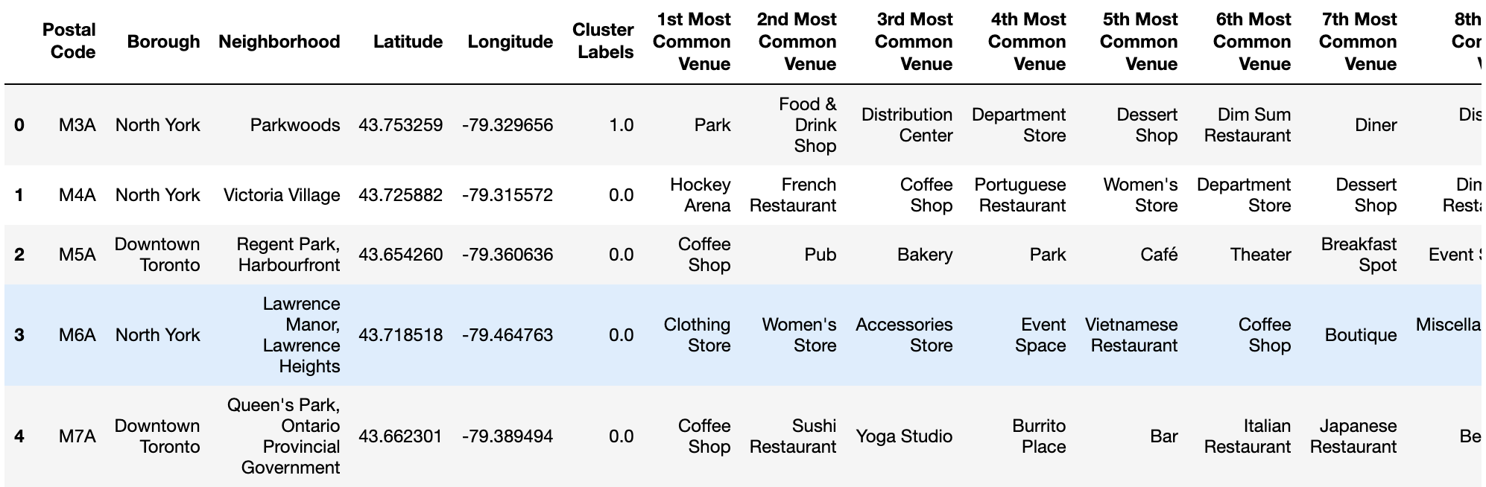

Each neighbourhood was plotted again on the map again and color-coded based on the cluster label. This visually represents all the similar neighbourhoods in GTA.

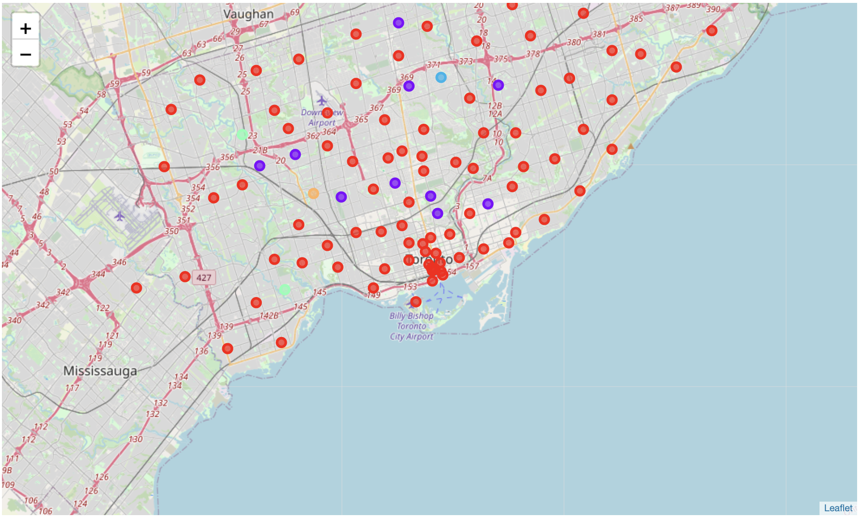

1. **RESULTS**

I tested the model by querying all neighborhoods with a ‘Baseball Field’. This resulted in a list of Neighborhoods plotted on a map.

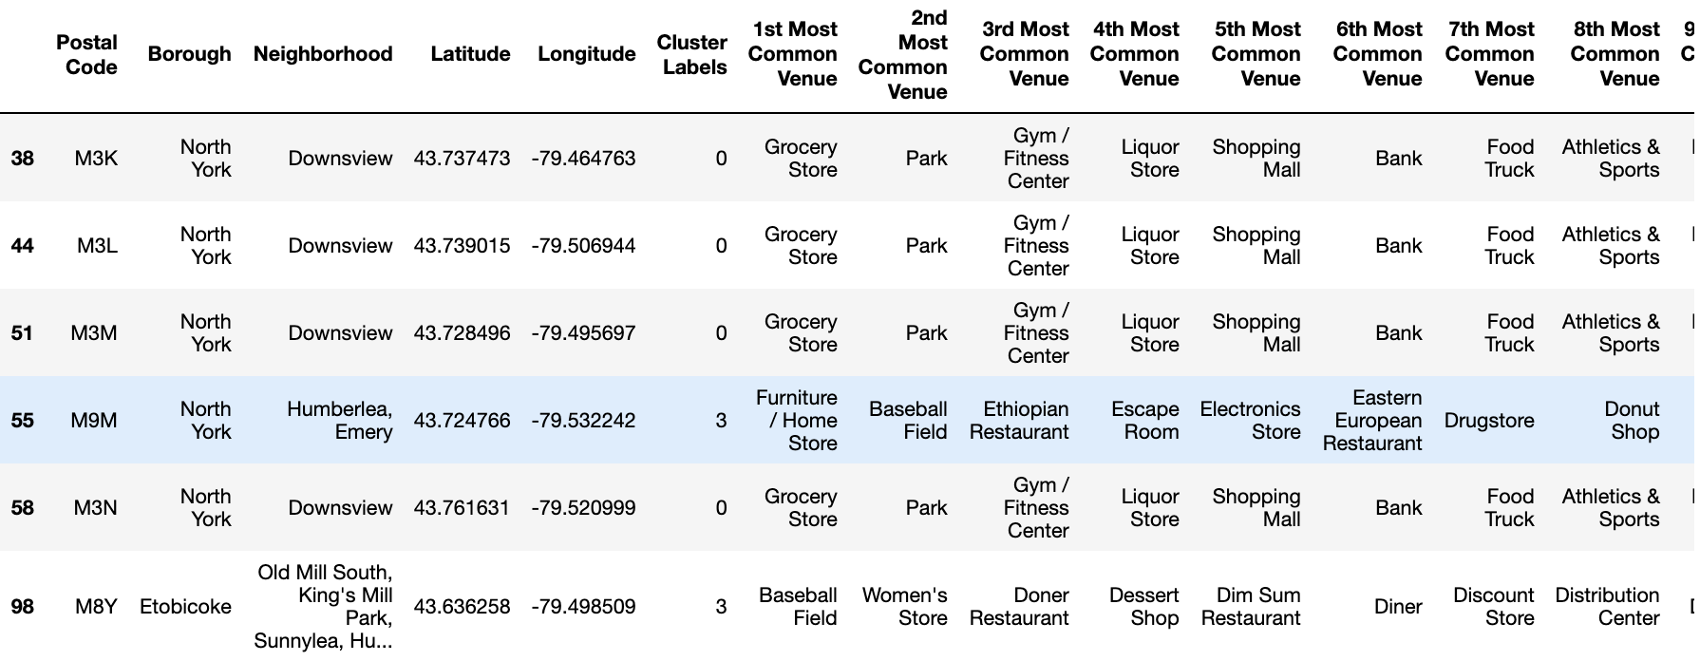

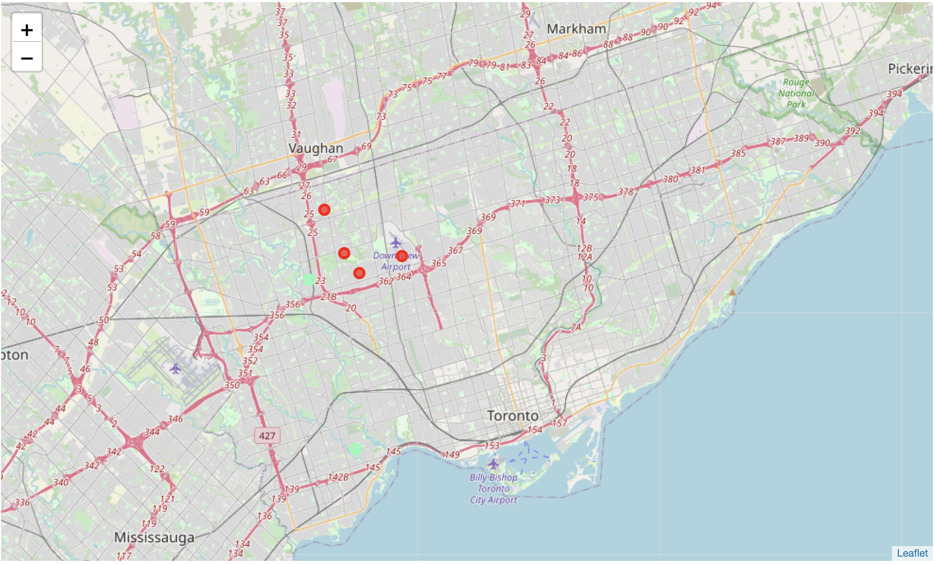

1. **CONCLUSION**

As seen above, any immigrant moving to Toronto can enter the amenities and get a list of best suited neighborhoods and display their locations on a map. This will help the user understand the types of neighborhoods in Toronto. Moreover, this model could be applied to cities other than Toronto and help anyone who is planning to move to that city.